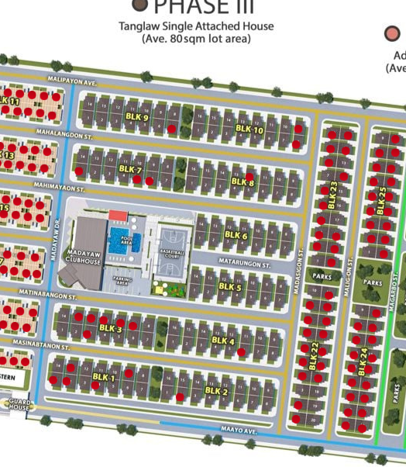
UPDATED AS OF JUNE 20, 2026

